**Java Swing** is a part of Java Foundation Classes (JFC) that is used to create window-based applications. It is built on the top of AWT (Abstract Windowing Toolkit) API and entirely written in java.

Unlike AWT, Java Swing provides platform-independent and lightweight components.

The javax.swing package provides classes for java swing API such as JButton, JTextField, JTextArea, JRadioButton, JCheckbox, JMenu, JColorChooser etc.

|  |  |  |
| --- | --- | --- |
| **No.** | **Java AWT** | **Java Swing** |
| 1) | AWT components are **platform-dependent**. | Java swing components are **platform-independent**. |
| 2) | AWT components are **heavyweight**. | Swing components are **lightweight**. |
| 3) | AWT **doesn't support pluggable look and feel**. | Swing **supports pluggable look and feel**. |
| 4) | AWT provides **less components** than Swing. | Swing provides **more powerful components** such as tables, lists, scrollpanes, colorchooser, tabbedpane etc. |
| 5) | AWT **doesn't follows MVC**(Model View Controller) where model represents data, view represents presentation and controller acts as an interface between model and view. | Swing **follows MVC**. |

Hierarchy of Java Swing classes

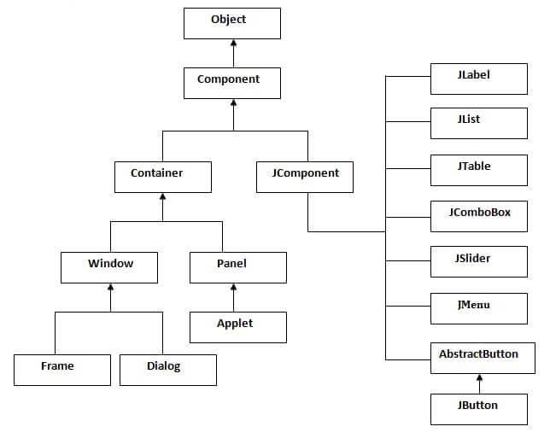

The methods of Component class are widely used in java swing that are given below.

|  |  |
| --- | --- |
| **Method** | **Description** |
| public void add(Component c) | add a component on another component. |
| public void setSize(int width,int height) | sets size of the component. |
| public void setLayout(LayoutManager m) | sets the layout manager for the component. |
| public void setVisible(boolean b) | sets the visibility of the component. It is by default false. |

There are two ways to create a frame:

* By creating the object of Frame class (association)
* By extending Frame class (inheritance)

simple swing example where we are creating one button and adding it on the JFrame object inside the main() method.

**import** javax.swing.*;

**public** **class** FirstSwingExample {

**public** **static** **void** main(String[] args) {

JFrame f=**new** JFrame();//creating instance of JFrame

JButton b=**new** JButton("click");//creating instance of JButton

b.setBounds(130,100,100, 40);//x axis, y axis, width, height

f.add(b);//adding button in JFrame

f.setSize(400,500);//400 width and 500 height

f.setLayout(**null**);//using no layout managers

f.setVisible(**true**);//making the frame visible

}

}

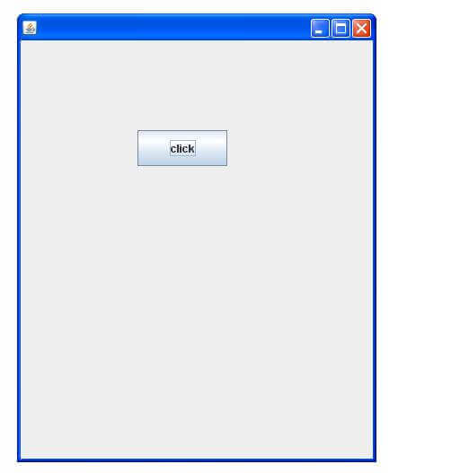

inherit the JFrame class, so there is no need to create the instance of JFrame class explicitly.

**import** javax.swing.*;

**public** **class** Simple2 **extends** JFrame{//inheriting JFrame

JFrame f;

Simple2(){

JButton b=**new** JButton("click");//create button

b.setBounds(130,100,100, 40);

add(b);//adding button on frame

setSize(400,500);

setLayout(**null**);

setVisible(**true**);

}

**public** **static** **void** main(String[] args) {

**new** Simple2();

}}

JButton class

The JButton class is used to create a labeled button that has platform independent implementation. The application result in some action when the button is pushed. It inherits AbstractButton class.

|  |  |
| --- | --- |
| **Constructor** | **Description** |
| JButton() | It creates a button with no text and icon. |
| JButton(String s) | It creates a button with the specified text. |
| JButton(Icon i) | It creates a button with the specified icon object. |
|  |  |
| **Methods** | **Description** |
| void setText(String s) | It is used to set specified text on button |
| String getText() | It is used to return the text of the button. |
| void setEnabled(boolean b) | It is used to enable or disable the button. |
| void setIcon(Icon b) | It is used to set the specified Icon on the button. |
| Icon getIcon() | It is used to get the Icon of the button. |
| void setMnemonic(int a) | It is used to set the mnemonic on the button. |
| void addActionListener(ActionListener a) | It is used to add the [action listener](https://www.javatpoint.com/java-actionlistener) to this object. |

**import** java.awt.event.*;

**import** javax.swing.*;

**public** **class** ButtonExample {

**public** **static** **void** main(String[] args) {

    JFrame f=**new** JFrame("Button Example");

**final** JTextField tf=**new** JTextField();

    tf.setBounds(50,50, 150,20);

    JButton b=**new** JButton("Click Here");

    b.setBounds(50,100,95,30);

    b.addActionListener(**new** ActionListener(){

**public** **void** actionPerformed(ActionEvent e){

            tf.setText("Welcome to Javatpoint.");

        }

    });

    f.add(b);

f.add(tf);

    f.setSize(400,400);

    f.setLayout(**null**);

    f.setVisible(**true**);

}

}

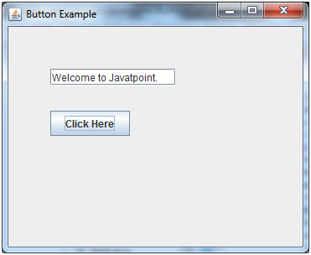

# **Java JLabel**

The object of JLabel class is a component for placing text in a container. It is used to display a single line of read only text. The text can be changed by an application but a user cannot edit it directly. It inherits JComponent class.

1. **public** **class** JLabel **extends** JComponent **implements** SwingConstants, Accessible
2. Commonly used Constructors:

|  |  |
| --- | --- |
| **Constructor** | **Description** |
| JLabel() | Creates a JLabel instance with no image and with an empty string for the title. |
| JLabel(String s) | Creates a JLabel instance with the specified text. |
| JLabel(Icon i) | Creates a JLabel instance with the specified image. |
| JLabel(String s, Icon i, int horizontalAlignment) | Creates a JLabel instance with the specified text, image, and horizontal alignment. |

1. Commonly used Methods:

|  |  |
| --- | --- |
| **Methods** | **Description** |
| String getText() | t returns the text string that a label displays. |
| void setText(String text) | It defines the single line of text this component will display. |
| void setHorizontalAlignment(int alignment) | It sets the alignment of the label's contents along the X axis. |
| Icon getIcon() | It returns the graphic image that the label displays. |
| int getHorizontalAlignment() | It returns the alignment of the label's contents along the X axis. |

**import** javax.swing.*;

**class** LabelExample

{

**public** **static** **void** main(String args[])

    {

    JFrame f= **new** JFrame("Label Example");

    JLabel l1,l2;

    l1=**new** JLabel("First Label.");

    l1.setBounds(50,50, 100,30);

    l2=**new** JLabel("Second Label.");

    l2.setBounds(50,100, 100,30);

    f.add(l1);

f.add(l2);

    f.setSize(300,300);

    f.setLayout(**null**);

    f.setVisible(**true**);

    }

    }

Output:

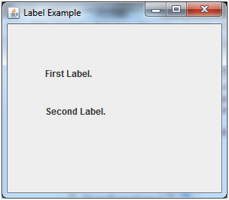

# **Java JTextField**

The object of a JTextField class is a text component that allows the editing of a single line text. It inherits JTextComponent class.

## **JTextField class declaration**

Let's see the declaration for javax.swing.JTextField class.

1. **public** **class** JTextField **extends** JTextComponent **implements** SwingConstants

### Commonly used Constructors:

|  |  |
| --- | --- |
| **Constructor** | **Description** |
| JTextField() | Creates a new TextField |
| JTextField(String text) | Creates a new TextField initialized with the specified text. |
| JTextField(String text, int columns) | Creates a new TextField initialized with the specified text and columns. |
| JTextField(int columns) | Creates a new empty TextField with the specified number of columns. |

### Commonly used Methods:

|  |  |
| --- | --- |
| **Methods** | **Description** |
| void addActionListener(ActionListener l) | It is used to add the specified action listener to receive action events from this textfield. |
| Action getAction() | It returns the currently set Action for this ActionEvent source, or null if no Action is set. |
| void setFont(Font f) | It is used to set the current font. |
| void removeActionListener(ActionListener l) | It is used to remove the specified action listener so that it no longer receives action events from this textfield. |

## **Java JTextField Example**

**import** javax.swing.*;

**class** TextFieldExample

{

**public** **static** **void** main(String args[])

    {

    JFrame f= **new** JFrame("TextField Example");

    JTextField t1,t2;

    t1=**new** JTextField("Welcome to Javatpoint.");

    t1.setBounds(50,100, 200,30);

    t2=**new** JTextField("AWT Tutorial");

    t2.setBounds(50,150, 200,30);

    f.add(t1); f.add(t2);

    f.setSize(400,400);

    f.setLayout(**null**);

    f.setVisible(**true**);

    }

    }

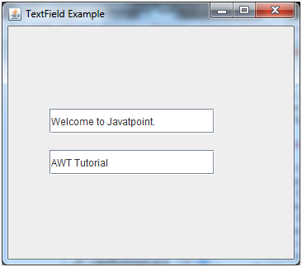

JRadioButton class

JTextArea class

JComboBox class

JTable class

JColorChooser class

JProgressBar class

JSlider class

Digital Watch

Graphics in swing

Displaying image

Edit menu code for Notepad

OpenDialog Box

Notepad

Puzzle Game

Pic Puzzle Game

Tic Tac Toe Game

BorderLayout

GridLayout

FlowLayout

CardLayout